E-Store

Manual

Version 1.0.2

1. **Login Module**

Please enter the username and password and click on submit button to login. The below are credentials username-> [jeevankulkarni10@gmail.com](mailto:jeevankulkarni10@gmail.com) and password is 12345678

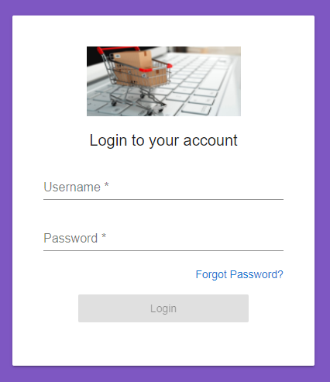

On invalid username and password error message will be appeared on screen.

To reset the password, click on forgot password? Link.

Enter the valid email address then link will sent to your registered mail id.

On successful login, Home screen will be appeared on screen below.

1. **Dashboard Module**

Below is the dashboard for E-Store module.

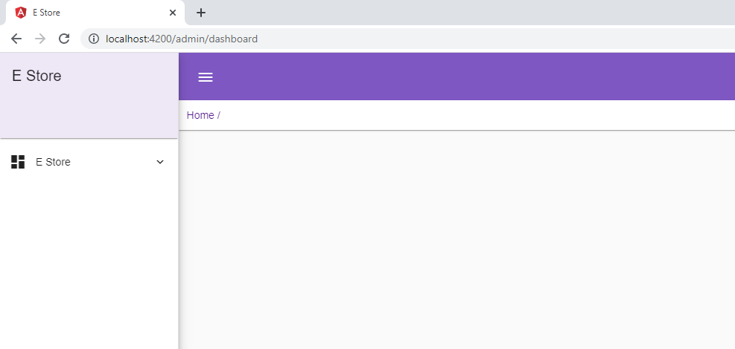

1. **Product -**

Please select the product and select the product from menu list.

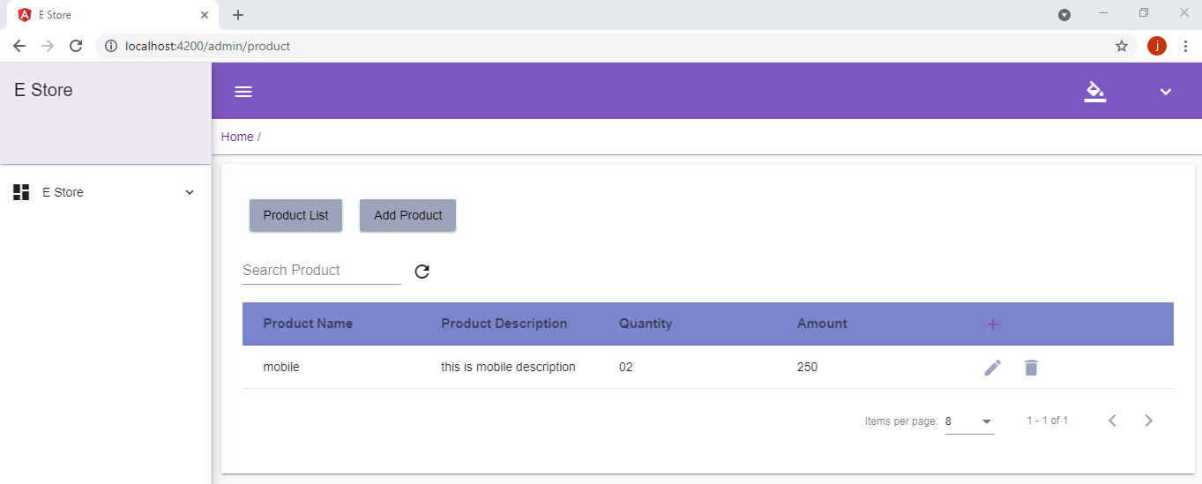

Then product page will be displayed on screen, click on Add Product button to add the product into system.

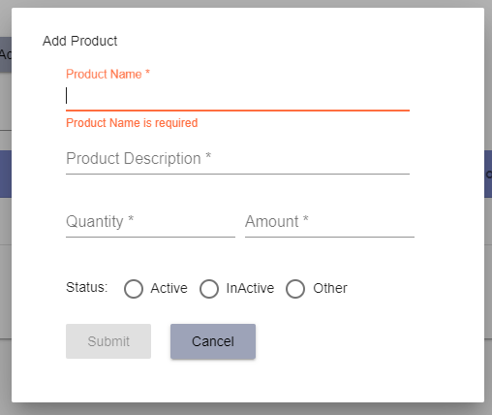

For update the product, go to product home page and click on edit button then window will be displayed on screen.

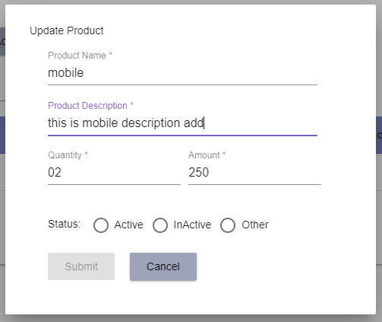

For delete product, Go to product home page and click on delete icon on screen.

